Placing ACLs

**Components:** PC, switch, router, server

**Theory:** A network access control list (ACL) is made up of rules that either allow access to a computer environment or deny it. In a way, an ACL is like a guest list at an exclusive club. Only those on the list are allowed in the doors. This enables administrators to ensure that, unless the proper credentials are presented by the device, it cannot gain access.

**Cisco Packet Tracer Setup:-**

1. Standard ACL **Implementation:**

**Step 1:** Arranging devices and creating connections and assign IP address as shown below

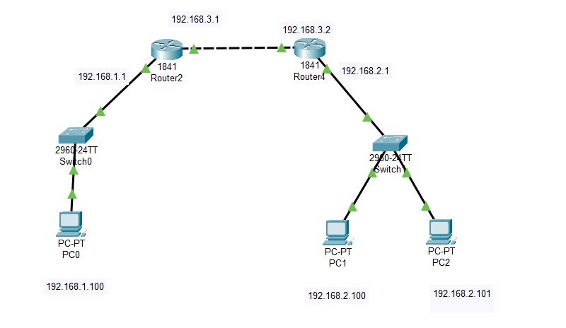

**Step 2**: creating access-list in router2 CLI as shown below

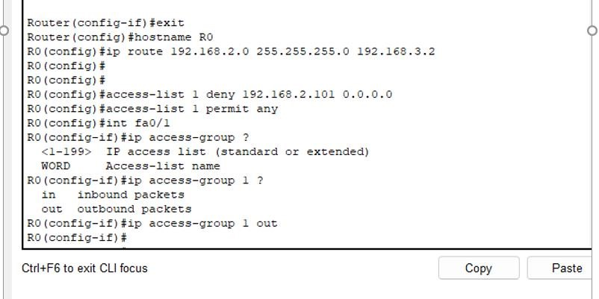

**Output:**

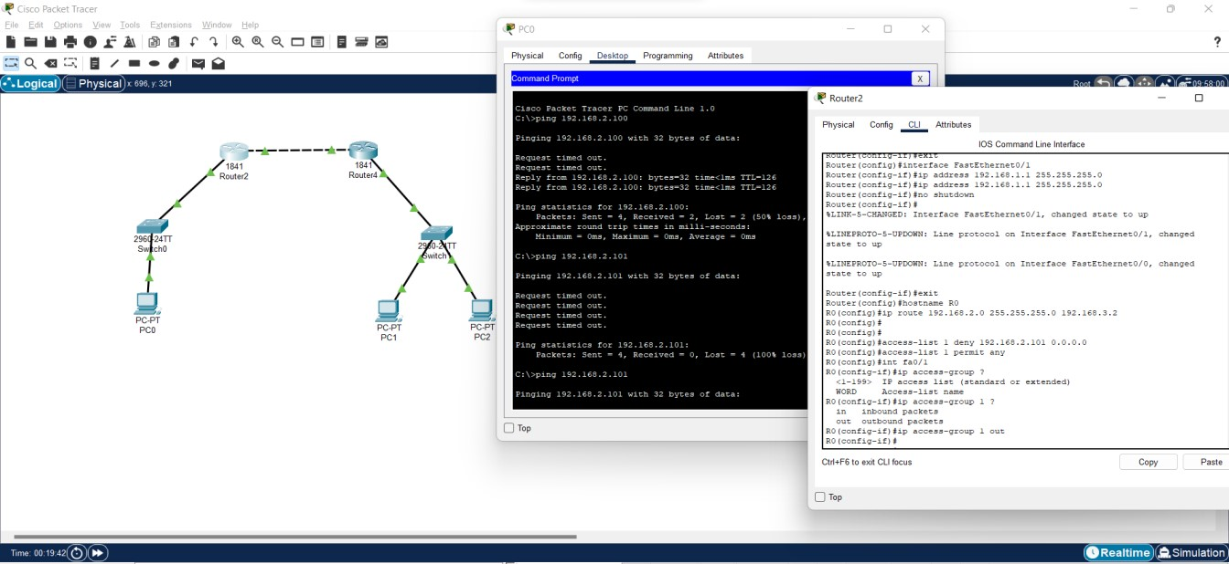

1. Extended ACL

**Implementation**

**Step 1:** Create the layout shown below and set the IP address accordingly

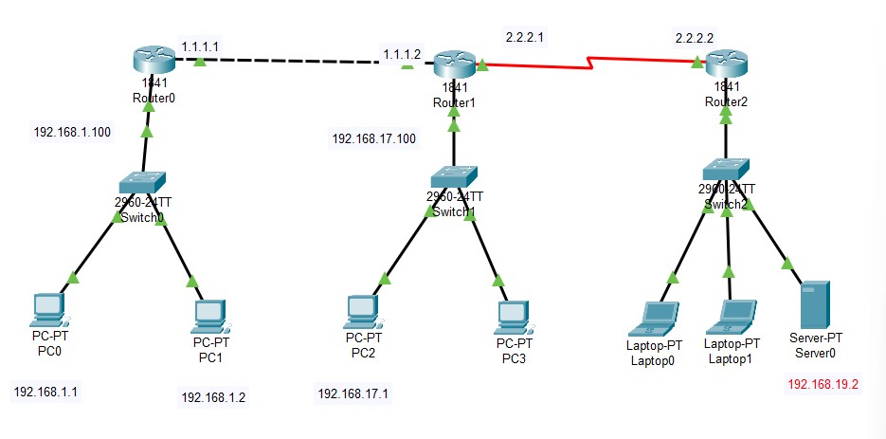

**Step 2:** configuring the RIP protocol

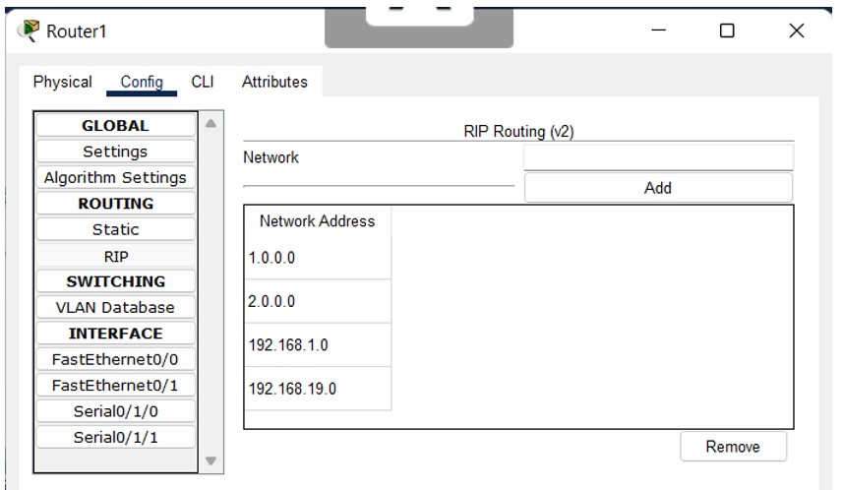

**Step 3**: Setting the access list in Router0 > CLI

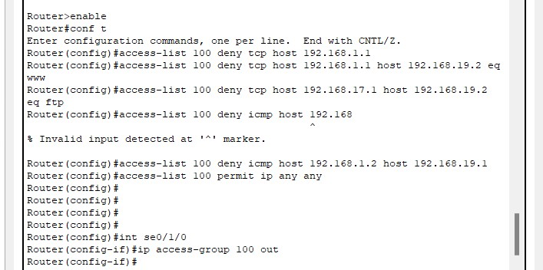

**Output:**

